EECE 200

Lecture 2 : Signals

- To be transmitted, data must be transformed to electromagnetic signals.

Analog and Digital Data
Data can be analog or digital.
• Analog data refers to information that is continuous; Analog data take on continuous values.
• Digital data refers to information that has discrete states. Digital data take on discrete values.

Analog and Digital Signals
• Signals can be analog or digital.
• Analog signals can have an infinite number of values in a range.
• Digital signals can have only a limited number of values
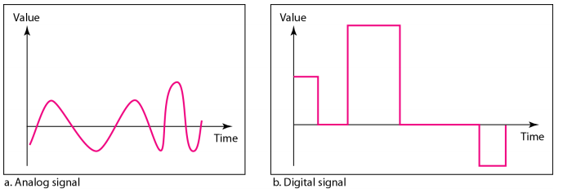

Periodic Analog Signals
In data communications, we commonly use periodic analog signals and non- periodic digital signals.
• Periodic analog signals can be classified as simple or composite.
– A simple periodic analog signal, a sine wave, cannot be decomposed into simpler signals.
– A composite periodic analog signal is composed of multiple sine waves.

Frequency
• Frequency is the rate of change with respect to time.
• Change in a short span of time means high frequency.
• Change over a long span of time means low frequency.

Phase
Phase describes the position of the waveform relative to time 0.
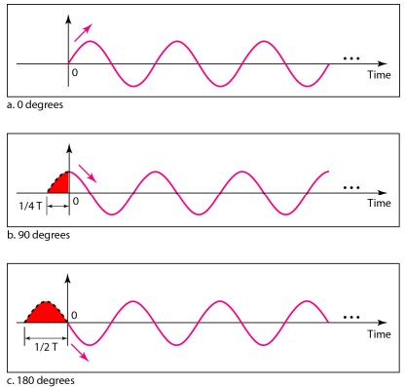

Time-domain and frequency-domain plots
A complete sine wave in the time domain can be represented by one single spike in the frequency domain.
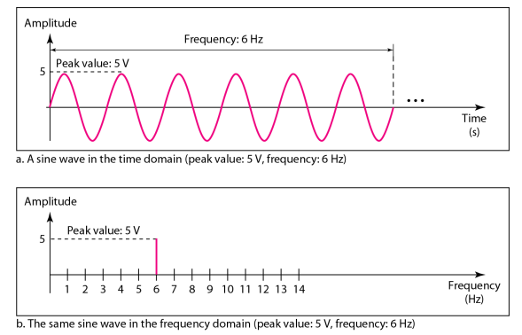

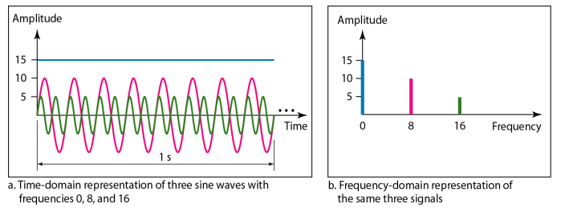

Signals and Communication
• A single-frequency sine wave is not useful in data communications.
• We need to send a composite signal, a signal made of many simple sine waves.
• According to Fourier analysis, any composite signal is a combination of simple sine waves with different frequencies, amplitudes, and phases.

Composite Signals and Periodicity
• If the composite signal is periodic, the decomposition gives a series of signals with discrete frequencies.
• If the composite signal is non-periodic, the decomposition gives a combination of sine waves with continuous frequencies.

- An example of a non-periodic composite signal is the signal propagated by an AM radio station. In Lebanon, each AM radio station is assigned a 10-kHz bandwidth. The total bandwidth dedicated to AM radio ranges from 530 to 1700 kHz.
- Another example of a non-periodic composite signal is the signal propagated by an FM radio station. In Lebanon, each FM radio station is assigned a 200-kHz bandwidth. The total bandwidth dedicated to FM radio ranges from 88 to 108 MHz.

Lecture 3 : Mathematical Tools

Image and Pixels
Definition of a Pixel: Short for Picture Element, a pixel is a single point in a graphic image. Graphics monitors display pictures by dividing the display screen into thousands (or millions) of pixels, arranged in rows and columns. The pixels are so close together that they appear connected.

Bits: Binary Digits
The number of bits used to represent each pixel determines how many colors or shades of gray can be displayed. For example, in 8-bit color mode, the color monitor uses 8 bits for each pixel, making it possible to display 2 to the 8th power (256) different colors or shades of gray.
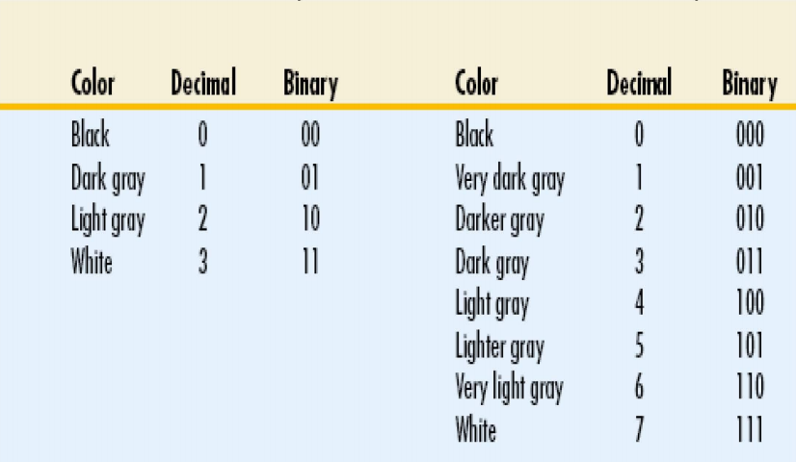

Base Numbers
• Base 10: We may use: 0, 1, 2, 4,…,9
• Base 2: Use 0 and 1
• Base 3: Use 0, 1, 2
• Base 8: 0, 1, 2, 3, 4, 5, 6, 7
• Base 16: 0, 1, 2, 3, 4, 5, 6, 7, 8, 9, A, B,
C, D, E, F

Conversion

- Binary -> Decimal
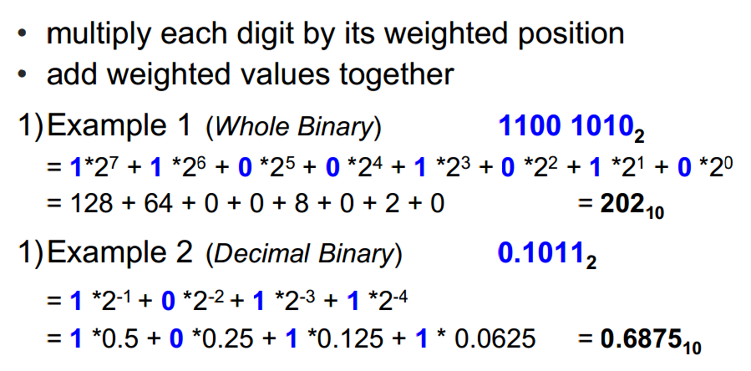

- Decimal -> Binary
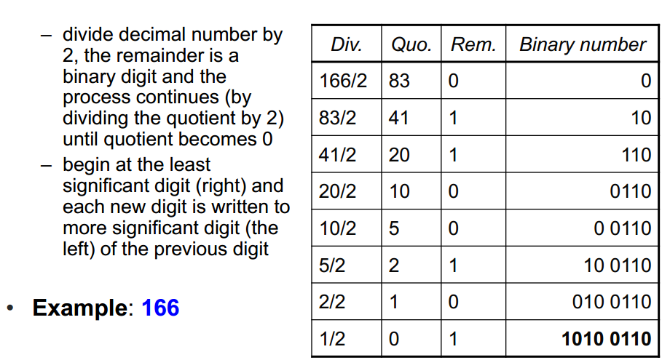

- Binary -> Octal/Hexadecimal
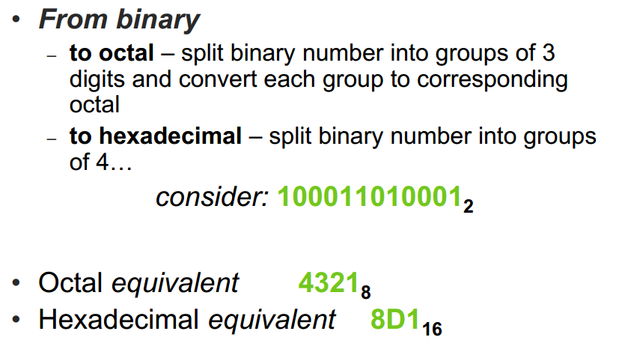

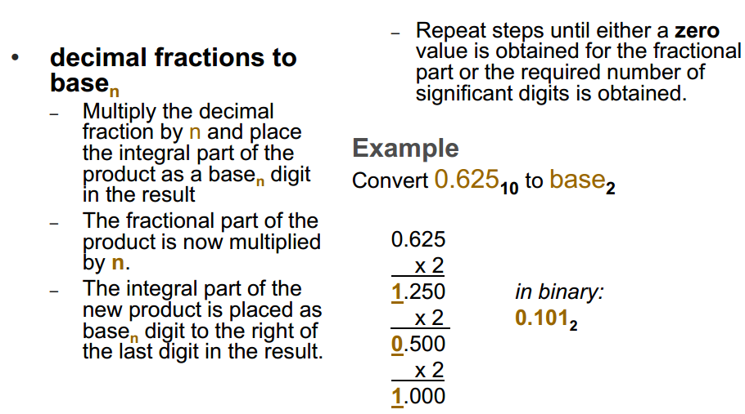

Lecture 4 : Circuits & Electronics

• Whenever there exists a difference in electric potential between two bodies connected by a conductor, electric charge will flow from the higher electric potential to the lower potential region.
• The flow of electric charges is called electric current or simply current.
• The electric current is measured in Amperes (A).
• Voltage is the amount of work required to move charges between two points.
• Voltage is measured in Volts (V).

Electric Circuits and Electronics
• Electric circuits: study of charges flowing in conductors
• Typically use AC signals
• Electronic circuits: study of charges flowing in semiconductors
• Typically use DC signals

• Electric circuit is the combination of various electrical components that are connected together.
• Examples of electrical components that build a circuit are:
– wires, switches, resistors, capacitors, diodes, transistors, and integrated circuits (ICs).
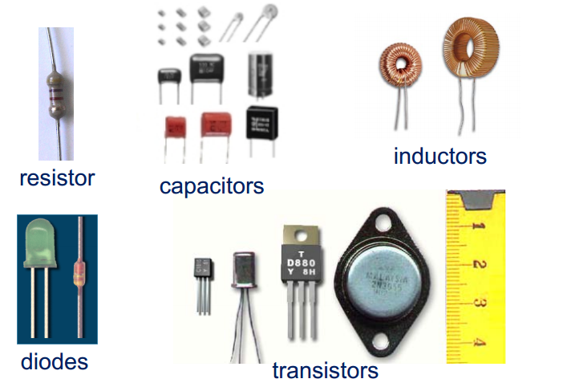

Integrated Circuits

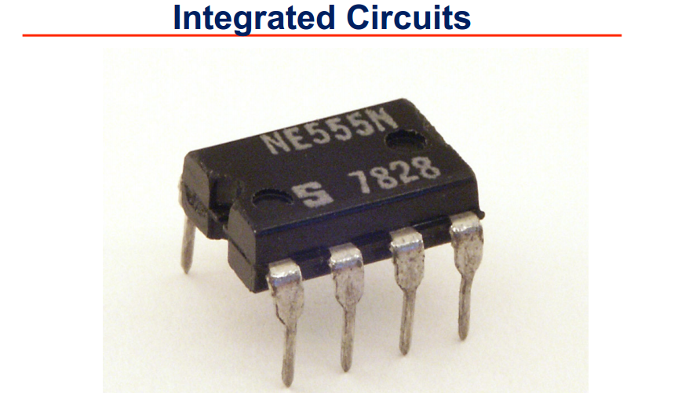

• IC’s result from the integration of previously separate transistors, resistors and capacitors, all on a single chip
• IC`s are used for a variety of devices, including microprocessors, audio and video equipment, cellular phones, biomedical devices, automobiles, etc.
• IC’s are distinguished by their small size, reliability, fast switching speeds, “low power consumption”, and mass production capability.
• It is believed that the digital revolution brought about by integrated circuits was one of the most significant occurrences in the history of mankind.
• ICs are fabricated in a layer process to print the integrated circuits on a wafer
• A wafer is diced into chips
• Each chip is tested and then packaged
• After packaging, the devices go through final testing

Why Digital?
• Numbers are easier to store
• They can be moved through space using:
- Copper wires (electrical voltage)
- Optical fibers ( light)
- Wireless channels (electromagnetic waves)
• They are less sensitive to physical problems
• Digital devices are increasingly being based on the transistor

The Transistor
• Invented in 1947 at Bell Labs, NJ
• Replaced the vacuum tube
• Acts as a switch:either ON or OFF
• Two states = binary arithmetic and binary digits or bits (0 or 1).
• Acts as an amplifier: to increase signal power

Moore’s Law
A prediction in 1965 by Gordon Moore, cofounder of Intel Corp., on how electronic technology will evolve
• RULE: Every 24 months or so, the
- Number (N1) of transistors doubles
- Speed of transistors doubles
- Area of transistors is cut in half
• From year Y1 to year Y2
N2 = 2(Y2 - Y1)/2 x N1

Lecture 7 : Project Management

Project Management Statistics
• The U.S. spends $2.3 trillion on projects every year, an amount equal to one‐quarter of the nation’s gross domestic product.
• The world as a whole spends nearly $10 trillion of its $40.7trillion gross product on projects of all kinds.
• More than sixteen million people regard project management as their profession; on average, a project manager earns more than $82,000 per year.*
• Famous business authors and consultants are stressing the importance of project management. As Tom Peters writes inhis book, Reinventing Work: the Project 50, “To win today you must master the art of the project!”

History of Project Management
• Modern project management began with the Manhattan Project, which the U.S. military led to develop the atomic bomb
• In 1917 Henry Gantt developed the Gantt chart as a tool for scheduling work in job shops
• In 1958, the Navy developed PERT charts
• In the 1970s, the military began using project management software, as did the construction industry
• By the 1990s, virtually every industry

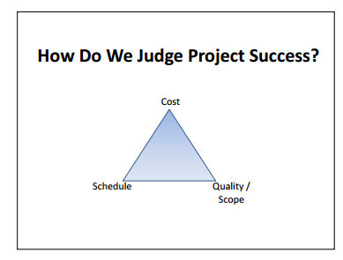

Project
A project is a “temporary” endeavor undertaken to create a “unique” product or service
■ If project output is not unique but repetitive, then this becomes a process
■ A project is composed of a number of related activities that are directed to the accomplishment of a single desired objective
■ A project starts when at least one of its activities is ready to start
■ A project is completed when all of its activities have been completed

What is Project Management
• Project Management definition: “The application of knowledge, skills, tools and techniques to project activities in order to meet or exceed stakeholder needs and expectations from a defined project”
■ An activity (also called a task):
– Must have a clear start and a clear stop
– Must have a duration that can be forecasted
– May require the completion of other activities before it begins – prerequisite activities
– should have some ‘deliverables’ for ease of monitoring
– Consumes resources
■ A project plan is a description of the project that divides it into sub‐projects and activities, indicating:
– The start and completion of each activity
– When (and how much) a resource is required
– The cost of each activity

Reasons for Project Planning

■ Establish directions for project team
■ Motivate normally disorganized people
■ Make allowance for risk – Assess amount of damage from possible delays & propose response
■ Well planned projects are executed on time and budget

Work Breakdown Structure
1) Start with: The Scope
Defines at the highest level what has to be done—what must be created and delivered to the project’s customers.
2) Create: The Work Breakdown Structure (WBS)
A top-down hierarchical description of the work required to produce what is called for in the Project Scope and achieve the mission,
• Provides approach for ‘decomposing’ the work into measurable units, which allows easier and more accurate estimates of duration and needed resources,
• Allows breakdown of work to deliverables, activities, tasks that can be assigned to an owner.
3) Based on the WBS, develop: The Project Schedule
Created by adding resource assignments, task work effort and duration estimates, and dependencies to all tasks in the WBS.

Creating WBS
■ Phase based approach (temporal decomposition)
■ Product based approach (physical decomposition)
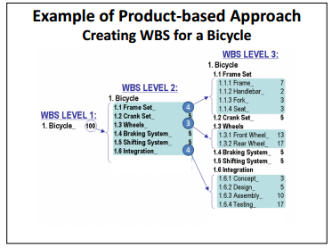
■ Function based approach (functional decomposition)
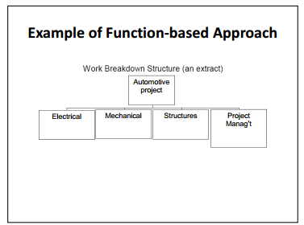
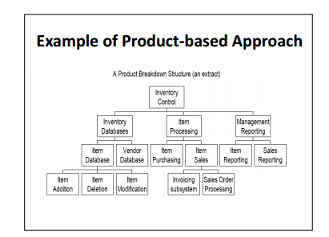
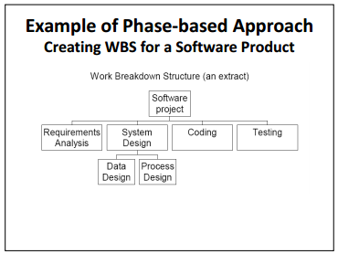

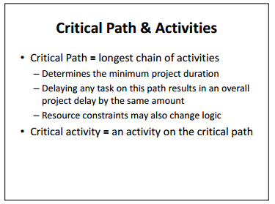
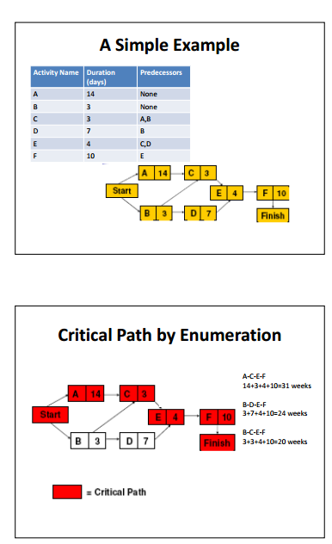

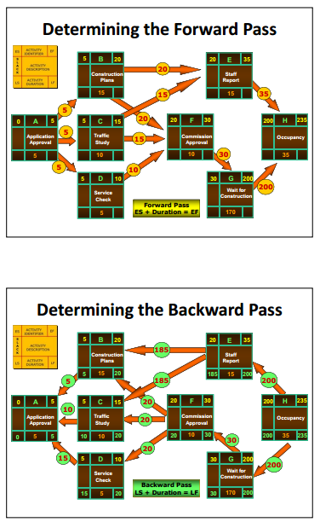
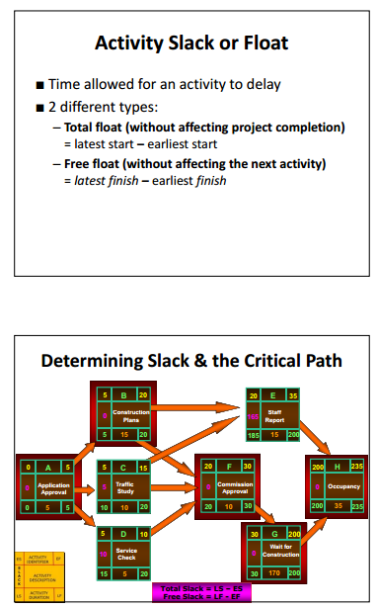

Lecture 8 : Computer Hardware

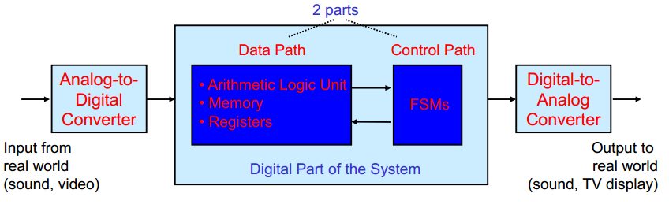
Digital systems have inputs and outputs that are represented by Binary digits (Bits) or groups of bits.

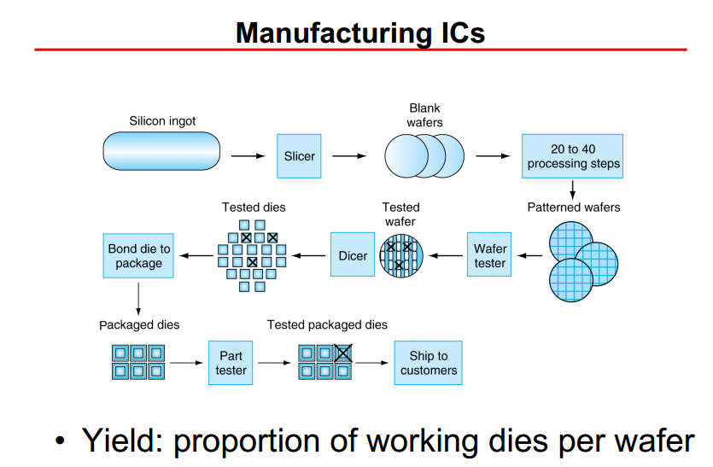

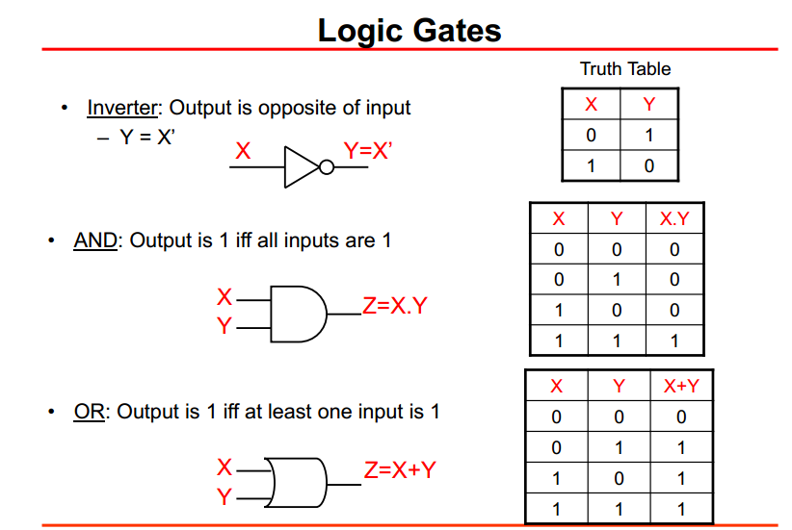
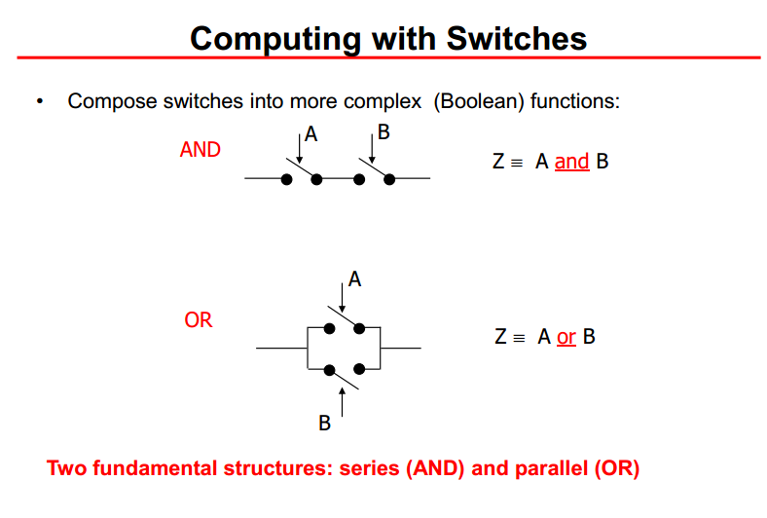
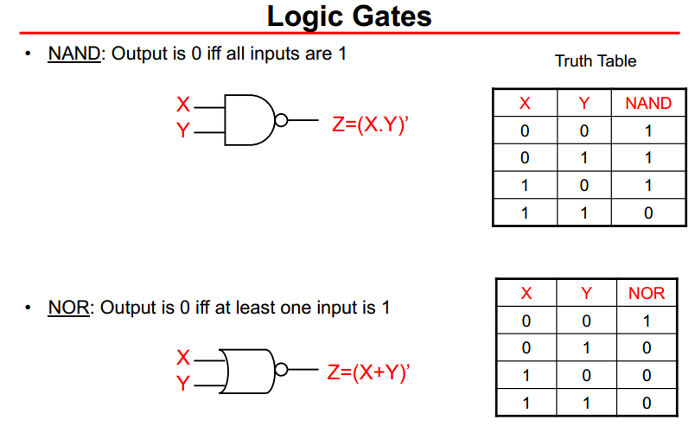
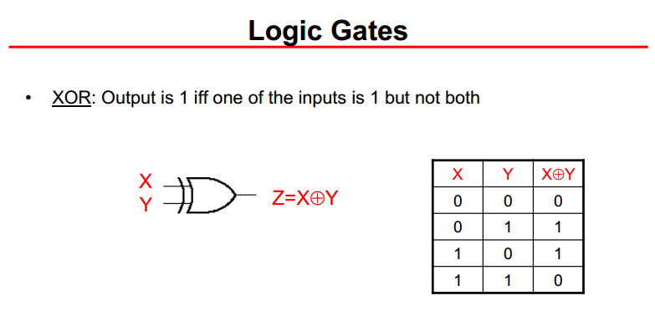

What is a Computer?
• A digital system that processes information according to a sequence of internally stored machine instructions called a program.
– Both the information to be processed and the instructions used to process them are represented as binary data.
• Different types of computers
– Servers
– General purpose desktop and laptop computers
– Ultra-mobile internet devices (smart phones, e.g., iphone)
– Special purpose or embedded computers

Memory
• Memory is used to store instructions (application programs) and data both inside and outside the computer.
• Primary memory
– Implemented using silicon technology
– Main memory (DRAM, ROM)
– Cache memory (SRAM)
• Secondary memory
– Implemented using magnetic, optical, or silicon technologies
• Hard disks
• Magnetic tapes
• DVDs
• Flash drives/memory sticks

Processor
• The “brains” of the computer
– Microprocessors
– Microcontrollers
– Special-purpose processors (e.g. GPUs, NPUs, DSPs)
• Datapath
– The part of the processor responsible for decoding and executing
instructions
– Consists of arithmetic and logic units and temporary storage elements called registers
• Control
– The part of the processor that coordinates the fetching and execution of instructions
– Also coordinates the operation of input, output, memory, and arithmetic/logic units

Lecture 9 : Communications

The Internet
- It is the inter-connection of a huge number of “small” networks (a.k.a. intranets)
- It is a “computers” network
- It is a “services” network
- It is a “communications” network
- It is “computers” (a.k.a. end-systems) running “services” (a.k.a. applications) over “communications”(a.k.a. telecom) infrastructures
- Internet… is a “communications” network
- Imagine a network composed of :
 -Billions of end-systems (”computers”)
 -Hundreds of thousands of routers
- Millions of content servers (web, email, social networks, etc.)
 -Billions of billions of bytes exchanged per day
 -Tens of communications technologies (wired & wireless) with giga- to tera-bytes per sec speeds
 -Hundreds of inter-operating software protocols
 -And, spanning the globe with high quality video, audio, and data services

